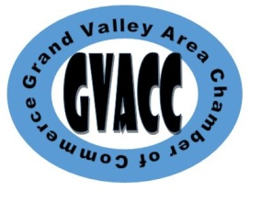 | New Membership  Application

Applicant DEMOGRAPHICS
Company Name:
Designated Representative:
Physical Address:
City: |  | State: |  | Zip Code:
Mailing Address:
City: |  | State: |  | Zip Code:
Phone Number: |  |  | Fax Number:
E-Mail Address:
Website Address:

Business Description
Please tell us about your business, business features, etc.:
Years in Business:

membership fee
Our annual membership fee is $60.00
Electronic Payment is accepted. Contact Amber Ballard at gvacctreasurer@yahoo.com
The membership fee is due when you submit your application.
Please mail this application to:
Grand Valley Area Chamber of Commerce
P O Box 261
Orwell, Ohio 44076
Or email to gvacctreasurer@yahoo.com

Signatures
Notice - Communication Consent:
By you providing your address, telephone number, fax number, and email address this gives the Grand Valley Area Chamber of Commerce permission to communicate to you by these means with information concerning events, and Chamber related activities. Your information will also appear in our Membership Directory, Chamber Newsletter and on our Website. Other Members and the public will have access to this information.
Signature & Title of applicant: |  |  |  |  | Date:
Revised 2/2021

